Analysis of Factors Influencing Seoul Bike Sharing Demand Using Tableau

Executive Summary
Bike-Sharing Systems have become an important part of the transportation network of modern cities as it provides a flexible, affordable and environmentally sustainable alternative to traditional modes of transportation. Unfortunately operators struggle to control demand variability caused by weather, seasonality, commuting patterns and special calendar events. My goal with this project was to analyze the Seoul Bike Sharing Demand Dataset (UCI Machine Learning Repository Dataset 560) and find factors that influence the demand for hourly bike rental.
I had two research foci that framed my analysis. The first was investigating what weather variables are most strongly related to bike rental demand and the second was to study the variation of demand in respect of hours of a day, seasons and holidays. Tableau Desktop was the tool this project used to perform exploratory data analysis, develop visualizations, and create interactive dashboards that support business decision-making.
The results showed a positive relationship between bike rentals and temperature and a negative relationship between bike rentals and rainfall and snowfall. The biggest negative impact to demand appears to be snowfall. Temporal analysis showed separate morning and evening commuting peaks with the greatest demand in the evening hours. Summer was the busiest for rentals and winter the least in demand. Holiday periods had lower average demand than non-holiday periods.
This study’s findings could help bike-sharing operators, transportation planners, and city governments in understanding demand patterns to help improve resource allocation, boost operational efficiency, and enhance customer experiences. This project serves to show how business intelligence tools turn raw operational data into useful business insights.

Introduction and Problem Rationale
Recently, bike-sharing programs have been integrated into the urban transport systems all over the world due to their convenience and ecological efficiency for the citizens and visitors and because these programs help cities lower their traffic problems and pollution. The number of city dwellers is rising. The transportation authorities and bike-sharing providers face an increasing complexity in dealing with demands.
One of the greatest difficulties of bike-sharing providers is demand variation because the success of business depends on the weather conditions, the time of the day, seasons and other environmental factors. In times of increased demand, popular sites can lack bikes, which causes poor performance of the program. If demand is low, on the other hand, there may be under-utilization of assets and high operating costs so effective management of these fluctuations requires a thorough understanding of the factors that influence bike rental behavior.
This project uses the assigned Seoul Bike Sharing Demand Dataset from UCI Machine Learning Repository (Dataset 560). This dataset contains hourly bike rental activity in Seoul, South Korea, with weather measurements and time-date variables that could impact demand. I hoped to discover meaningful patterns and offer actionable insights by employing business analytics methodologies and Tableau visualizations. As such my research is motivated by two broad questions:
RQ1: What weather variables are most strongly correlated with the hourly bike rental demand and in what direction?
RQ2: How do different time periods (hour of day, season, holiday) affect the demand for bike rentals?
The primary data set that will be used in this study is the Seoul Bike Sharing Demand Data Set (Data Set 560), sourced from the UCI Machine Learning Repository. This data set was donated in February 2020 and serves as a source of data on demand forecasting of transport, urban mobility analysis, and improvement of bike sharing systems. The data relates to the hourly public bicycle rental in Seoul’s massive, world famous bike sharing scheme. The time span covered by the observations spans over one entire year from December 1, 2017, to November 30, 2018, providing 8,760 observations (24 * 365 = 8,760). There is no data missing, and the license for the dataset is Creative Commons Attribution 4.0 International (CC BY 4.0).
With current techniques used to capture data, bike-sharing systems have been able to collect large volumes of data that can be used to analyze customer behavior, allocate resources effectively, and improve decision making. The Seoul dataset proves to be very useful because it brings together three key elements, namely measures of demand for rental services, measurements of weather, and temporal information. Such a multivariate dataset makes it possible for researchers and analysts to consider the interaction of all the above-mentioned factors that is crucial for tackling practical issues faced in urban transportation.
This dataset includes 14 different variables (one of which is the target variable) which made it suitable for visualization and further analysis in Tableau. Its hourly frequency of collection of data is crucial because it allows analyzing short-term trends that would be hidden in case of daily and monthly data aggregations.
Record Description
Each observation in the dataset represents a unique hourly interval within the study period. This hourly granularity offers substantial analytical advantages. First, it enables accurate identification of intra-day demand peaks linked to commuting, learning, and recreational needs. Second, it provides enough statistical power to analyze seasonal and weather effects in minute detail. Third, it has high compatibility with the techniques of time series visualization in Tableau such as trends, seasonality, and interactive dashboards.
In comparison with coarser data aggregation, such as daily or monthly summary reports, hourly data provide a more realistic picture of user demand since that demand can fluctuate very widely on a single day depending on rush hours, weather conditions, or changes in schedules. This resolution enabled identification of demand cycles, operational bottlenecks, such as shortage of stations during peaks, and recovery from disruptions.
Variables Description
The dataset encompasses weather-related, temporal, and operational variables. A comprehensive data dictionary is provided in Table 1 below, summarizing each attribute’s name, type, description, units, and analytical relevance.
Table 1: Data Dictionary for Seoul Bike Sharing Demand Dataset

Variable | Description
Date | Calendar date of each observation.
Rented Bike Count | Number of bicycles rented during each hour (target variable).
Hour | Hour of the day (0–23) used to analyze daily demand patterns.
Temperature (°C) | Ambient air temperature.
Humidity (%) | Relative humidity level.
Wind Speed (m/s) | Average wind speed during the observation period.
Visibility (10 m) | Visibility distance under current weather conditions.
Dew Point Temperature (°C) | Indicator of atmospheric moisture and comfort.
Solar Radiation (MJ/m²) | Amount of solar radiation received during the hour.
Rainfall (mm) | Hourly rainfall amount.
Snowfall (cm) | Hourly snowfall amount.
Seasons | Winter, Spring, Summer, or Autumn.
Holiday | Indicates whether the observation occurred on a holiday.
Functioning Day | Indicates whether the bike-sharing system was operating.
Table 1 is an overview of the variables that were used in this study. This dataset includes weather variables, temporal variables, and operational variables which aid in answering the two research questions. Weather variables were utilized to examine the impact of the environment on bike rentals while temporal variables such as hour, season, and holiday were used to identify patterns in demand.
Importance of the Dataset and Relationship to Research Questions
The Seoul Bike Sharing Demand dataset is incredibly appropriate for use in business intelligence. It contains a number of variables that provide sufficient information for conducting exploratory analysis aimed at uncovering demand drivers, analyzing system performance, and making evidence-based suggestions. The structured nature of the dataset and lack of significant data quality problems make it a perfect fit for exploratory analysis and visualization using Tableau.
Variables of the dataset correspond perfectly to the two research questions stated in the project. First of all, RQ1 (impact of weather) can be analyzed with help of such variables as Temperature, Humidity, Wind Speed, Visibility, Dew Point Temperature, Solar Radiation, Rainfall, and Snowfall. Bike usage is very sensitive to weather conditions, thus those variables allow predicting rider behavior with high precision.
For RQ2 (temporal patterns), variables including Date, Hour, Seasons, and Holiday enable detailed analysis of recurring demand cycles. Hourly data supports identification of commuting peaks, seasonal comparisons reveal long-term fluctuations, and the Holiday indicator helps distinguish work-related commuting from leisure travel. The Functioning Day variable adds operational context, ensuring analyses reflect realistic system availability. This integrated design makes the dataset particularly powerful for visual analytics.
Data Preparation and Preprocessing Workflow
Before the analysis I imported the Seoul Bike Sharing Demand Dataset into Tableau Prep as a CSV text file and initially looked through the variable definitions, validating data types, and confirmed that the dataset structure aligned with my initial project objectives.
The first preprocessing step involved verifying variable classifications. Numerical fields such as temperature, humidity, rainfall, snowfall, solar radiation, and rented bike count were identified as measures. Categorical variables including Seasons, Holiday, and Functioning Day were classified as dimensions. Proper classification ensured that Tableau could correctly generate charts, trend lines, and aggregations.
A data quality assessment was also performed to identify missing values, duplicate records, and formatting inconsistencies. The dataset is well structured and contains no significant missing values or duplicate observations requiring removal. Because the dataset was already prepared for analytical use, extensive cleaning procedures were unnecessary.
Although the project proposal considered creating additional calculated fields and derived variables, the original dataset contained sufficient information to answer the research questions. As a result, no major feature engineering activities were required. The existing weather, seasonal, and temporal variables provided adequate support for exploratory analysis and visualization development.
As a result of preprocessing, it became clear that the data set was already suitable for analysis using Tableau, and therefore the major part of the project would be devoted to exploring the data, creating dashboards, and performing business intelligence.

Section 5: Tableau Visualization, Analysis, and Findings
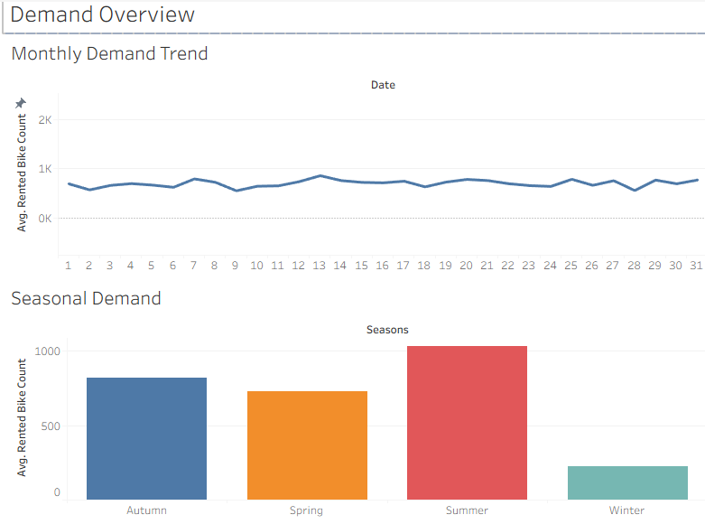

Figure 1. Demand Overview Dashboard

Overview of Analytical Approach
This project used Tableau Desktop for exploratory data analysis to address the research questions from the project proposal. From there, three different dashboards were created: Demand Overview Dashboard, Weather Impact Analysis Dashboard, and Temporal Demand Patterns Dashboard. Collectively, these three dashboards help provide insight into the elements that affect the bike-sharing demand in Seoul.
The analysis included uncovering the relationships between the weather parameters and bike rental behavior along with discovering the repetitive temporal demand patterns. Scatter plot, line chart, bar chart, and trend line visualizations were used in the process.
I started with exploratory data analysis to look for trends and relationships in the data before drawing any conclusions. Tableau served as the main instrument of analysis because of its interactive visualizations which help interpret large data sets. Scatter plots helped identify the relationship between continuous weather variables and rental demand, while line graphs were chosen to depict demand changes over time. Bar graphs were applied in order to compare average demand for different categories including holidays and seasons. The trend lines were included in the scatter plots in order to depict the trend of relations between weather variables and demand. This mix of visualization helped answer each question from different angles and made results comprehensible for decision-makers even without statistical knowledge.

Weather Impact Analysis (RQ1)
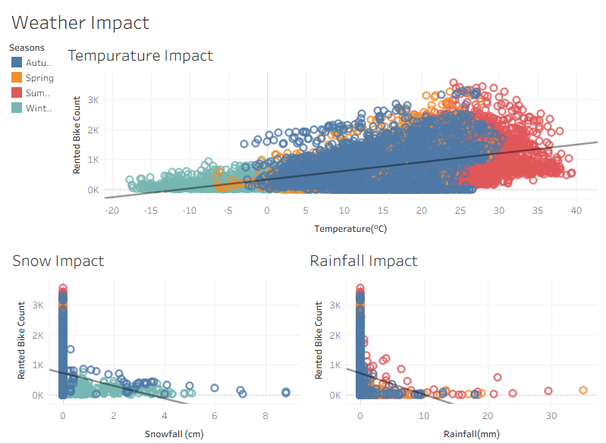
Figure 2. Weather Impact Analysis Dashboard
The first research question sought to determine which weather variables demonstrate the strongest relationship with bike rental demand.

Temperature Impact
The temperature scatter plot revealed a strong positive relationship between temperature and bike rental demand. As temperatures increased from winter conditions toward moderate and warm conditions, rental activity increased substantially. Rental counts were usually highest between 20 and 30 degrees. The relationship is not purely linear due to the fact that seasonality and holiday periods also affect demand. Yet it is still clear from the trend that increasing temperatures lead to increasing demand for bikes. The seasonal coloring in the scatter chart only confirmed this statement, as it is evident that all summer points had higher rental counts than winter ones.
Temperature was found to be the strongest positively correlated weather factor. Though the rising curve shows that warm weather generally promotes biking, the scatter diagram clearly shows that temperature cannot solely determine changes in the demand pattern since, at the same temperature levels, there are great fluctuations caused by other factors such as time of the day, season, holidays, rain, and others. For instance, warm weather on a weekday during peak hour will attract more customers than warm weather on holidays. The above facts show that bike-sharing demand depends on several factors that interact with each other.
Operationally, temperature can be used as a predictor for the future demand. If the forecast promises a pleasant temperature, the bikes can be increased at the stations where high ridership is normally seen. Conversely, cold weather is an indication of low demand times and therefore allows operators to perform maintenance and redistributive operations without affecting customers.

Rainfall Impact
Rainfall demonstrated a negative relationship with bike rental demand. Most observations occurred at zero rainfall because precipitation is relatively infrequent compared to dry weather conditions but when rainfall did occur, rental counts generally decreased.
The trend line displayed a downward slope, indicating that increasing rainfall is associated with lower demand. Even moderate rainfall events corresponded with noticeable reductions in rental activity. Heavy rainfall events produced the lowest observed demand levels which illustrates how important a factor precipitation is for operational planning and demand forecasting so Bike-sharing operators could benefit from incorporating weather forecasts into resource allocation decisions.
While most of the data were recorded with zero rainfall, the visualization makes it quite clear that the more rainfall there is, the fewer bikes get rented. This pattern is quite reasonable in relation to expectations of how bike renters will behave, as rainfall negatively impacts comfort and makes trips riskier. Moreover, even slight levels of rainfall led to drops in rentals, and bigger rainfalls resulted in some of the smallest rental numbers in the dataset. It becomes evident that rainfall should become one of the main variables to consider when making short-term demand forecasts.

Snowfall Impact
Among all weather variables examined, snowfall demonstrated the strongest negative relationship with demand. The snowfall scatter plot showed a sharp decline in rental activity as snowfall increased.
The majority of high-demand observations occurred when snowfall was absent. Once snowfall began to accumulate, rental counts fell dramatically. This pattern is consistent with expectations because snow creates safety concerns, reduces riding comfort, and limits transportation accessibility.
The snowfall analysis confirms that winter weather conditions substantially suppress bike-sharing demand and should be incorporated into operational forecasting models.

Temporal Demand Analysis (RQ2)
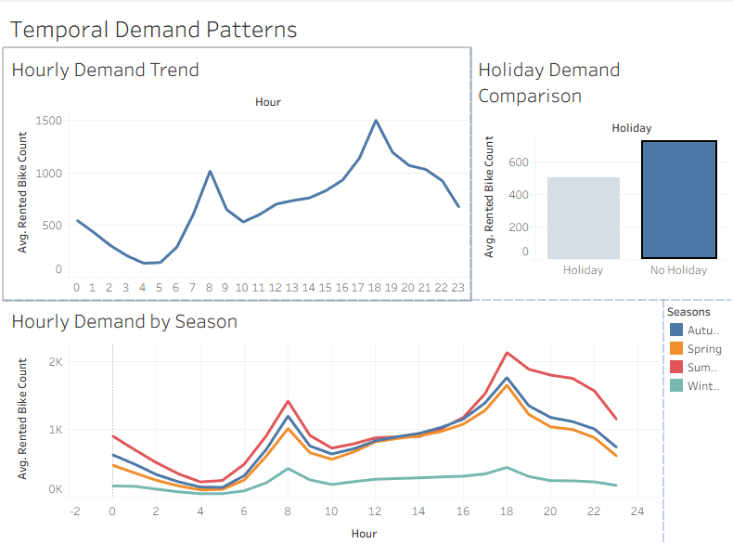
Figure 3. Temporal Demand Patterns Dashboard
The second research question focused on understanding how bike rental demand varies across time.

Hourly Demand Trend
The hourly demand trend chart revealed a classic bimodal commuting pattern. Demand sat relatively low during overnight hours and reached its minimum between approximately 4:00 AM and 5:00 AM. At around 6:00 AM, rental activity increased rapidly as commuters started traveling to work and school. The first major demand peak occurred around 8:00 AM. After the morning peak, demand declined during late morning hours before gradually increasing again throughout the afternoon. The highest level of demand occurred around 6:00 PM, indicating that evening commuting activity exceeds morning commuting activity. The existence of two distinct peaks suggests that commuting behavior is one of the most important drivers of bike-sharing demand.
The repeated occurrence of early and late peaks indicates that the main cause behind the demand for bike sharing in Seoul is the act of commuting. Early peaks indicate demand by individuals who commute to work or schools, whereas the late peaks could be explained by return commuting or leisure activities in the evenings. The gradually increasing trend of demand from the afternoon onwards suggests that there is an even demand throughout the day rather than only at commutes.

Holiday Demand Comparison
The holiday comparison chart demonstrated that average rental demand was lower on holidays than on non-holiday periods. This finding suggests that commuting-related trips account for a substantial portion of total bike rentals because on holidays, many individuals do not travel to work or school and there is a reduced demand during traditional commuting periods. Although recreational cycling remains present, overall rental activity decreases compared to normal working days.

Hourly Demand by Season
The seasonal hourly demand chart provided additional insight into demand behavior. Summer exhibited the highest rental activity across nearly all hours of the day, while winter consistently displayed the lowest demand. Despite substantial differences in magnitude, all seasons maintained a similar overall shape characterized by morning and evening peaks. This finding suggests that commuting behavior remains relatively stable throughout the year, even though weather conditions significantly affect overall ridership levels. The strongest demand occurred during summer evenings, when favorable weather conditions and commuting activity combined to produce the highest rental counts observed in the dataset.

Dashboard Interaction Framework
Each of the three dashboards was created with varying levels of analytics capabilities while remaining easy to interpret for both technical and non-technical decision makers. First, the Demand Overview Dashboard features monthly and seasonal trends depicting the overall performance of the system. Secondly, the Weather Impact Analysis Dashboard concentrates exclusively on correlations between weather conditions and the demand for renting using scatter plots and trend lines. Lastly, the Temporal Demand Patterns Dashboard studies recurring usage patterns through hourly trends, seasonal trends, and holiday trends.
The interaction feature of Tableau greatly increases the practical value of these dashboards. Filters can be used to specify certain seasons or weather conditions, making it possible to study demand patterns under various scenarios of operation. Instead of using static reports, decision-makers can explore variable interrelations and identify patterns to make their operational decisions on. Interaction capability is one of the most powerful features of Tableau as a BI tool, since it allows transforming huge amounts of historical data into useful visual information.

Data-Driven Operational Recommendations
The analysis identified several opportunities to improve the efficiency and effectiveness of the Seoul Bike Sharing program.

Fleet Redistribution Strategies
The demand in the hourly analysis shows two primary demand peaks at 8:00 AM and 6:00 PM, which means that the operator needs to focus on making bicycles available during the commutes through repositioning them to areas of high demand before these peaks occur.

Weather-Based Operational Planning
The weather analysis showed that rainfall and snowfall significantly reduce bicycle demand, while warmer temperatures increase ridership. Operators should incorporate weather forecasts into daily planning activities. During periods of heavy rain or snow, maintenance work and other operational tasks can be scheduled because demand is expected to decrease. Using weather forecasts can improve efficiency and reduce unnecessary operating costs.

Seasonal Resource Allocation
Demand varied substantially across seasons, with summer producing the highest rental activity and winter producing the lowest. These findings suggest that staffing levels, bicycle availability, and maintenance resources should be adjusted according to seasonal demand patterns. Higher-demand seasons require additional operational support, while lower-demand periods provide opportunities for preventative maintenance and system improvements.

Infrastructure Planning
The analysis demonstrated that bike-sharing demand is concentrated during specific hours and seasons. Transportation planners can use these findings to identify locations where additional station capacity or cycling infrastructure may be needed. Expanding bike lanes and improving station accessibility may help support future ridership growth while improving the overall user experience.

Data-Driven Decision Making
The Tableau dashboards that were developed in this project demonstrated the value of business intelligence tools for transportation planning. Interactive visualizations allow decision-makers to monitor demand patterns, evaluate environmental influences, and make evidence-based operational decisions and use of analytics can help bike-sharing operators improve service quality and respond more effectively to changing demand conditions.

Limitations of the Analysis
One consideration I would like to note pertaining to the project is that several limitations should be weighed when interpreting the findings of this study. The first being that the dataset only contains one year of observations and even though the data provides a comprehensive view of bike-sharing activity during that period a longer time horizon may reveal additional trends and demand patterns that are not visible within a single year.
Second, the dataset does not contain rider demographic information such as age, gender, income, or trip purpose. These factors may influence bicycle usage and could provide additional insight into demand behavior. Similarly, station-level location data is not included, preventing analysis of geographic demand patterns throughout Seoul.
Third, the analysis is concerned mainly with descriptive analytics and visualization instead of predictive modeling. Although the dashboards effectively detect the associations and trends, they do not prove the causation and forecast the future demands. Future studies should try to include regression analysis, forecasting, and machine learning methods to predict more accurately.
However, even with those limitations, the data set gives much information about the impact of the environment and time on the demands for bike sharing. The visualizations created in Tableau have been successful in answering the research questions and providing recommendations.

Conclusion
This project used the Seoul Bike Sharing Demand Dataset to analyze the factors affecting bike rental demand in Seoul. Using Tableau-based visualization and exploratory analysis, our studies identified significant relationships between weather conditions, temporal factors, and bike rental demand.
Temperature demonstrated a positive relationship with demand, while rainfall and snowfall exhibited negative relationships. Temporal analysis revealed strong commuting patterns characterized by morning and evening peaks. During the summer season, there was peak demand, but during the winter season, the level of usage was minimal. Additionally, the holiday seasons were characterized by low average demand levels compared to other non-holiday seasons. From the results above, it is evident that operational planning using data will enhance the efficiency of the bike-sharing program by informing better decisions using business intelligence techniques.
This project also demonstrates the value of business intelligence techniques in transportation management. In the future research could incorporate additional years of data, station-level information, and predictive modeling techniques to improve forecasting accuracy. Variables such as rider demographics, special events, and public transportation usage could provide additional insight into bike-sharing behavior but despite these limitations, the current analysis successfully identified key environmental and temporal drivers of demand and generated practical recommendations for improving bike-sharing operations in Seoul.

References
Few, S. (2013). Information dashboard design: Displaying data for at-a-glance monitoring. Analytics Press.
Han, J., Kamber, M., & Pei, J. (2022). Data mining: Concepts and techniques. Morgan Kaufmann.
UCI Machine Learning Repository. (n.d.). Seoul Bike Sharing Demand Dataset (Dataset 560). University of California, Irvine. https://archive.ics.uci.edu/dataset/560/seoul+bike+sharing+demand

Appendix
Appendix A: Demand Overview Dashboard Screenshot

Appendix B: Weather Impact Analysis Dashboard Screenshot

Appendix C: Temporal Demand Patterns Dashboard Screenshot


